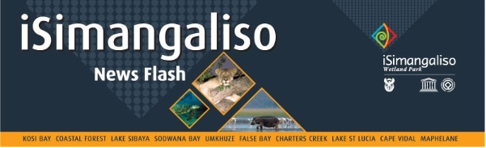
MEDIA INVITATION
11 August 2025
DEPUTY MINISTER SINGH TO LEAD THE SOUTHERN AFRICAN ELEPHANT INDABA IN HLUHLUWE, KWAZULU-NATAL
The Deputy Minister of Forestry, Fisheries and the Environment (DFFE), Mr Narend Singh, will lead the Southern African Elephant Indaba on 12 and 13 August 2025 at Bonamanzi Game Reserve in Hluhluwe, KwaZulu-Natal.
The Indaba will bring together government, conservation experts, community leaders and partner organisations to discuss the future of elephant conservation in South Africa. Discussions will focus on:
- Balancing elephant population management with community needs,
- Strengthening anti-poaching strategies,
- Promoting coexistence between wildlife and people, and
- Exploring sustainable tourism and economic opportunities linked to elephant conservation.
With South Africa’s elephant populations facing increasing pressures from habitat loss, human-wildlife conflict and illegal trade, the Indaba will focus on developing actionable strategies that safeguard elephants while supporting communities living near protected areas.
Members of the media are invited to attend and cover the Indaba as follows:
DAY 1
Dates: Tuesday, 12 August 2025
Time: 09:00
Venue: Bonamanzi Game Reserve, Hluhluwe, KwaZulu-Natal
DAY 2
Dates: Wednesday, 13 August 2025
Time: 09:00
Venue: Bonamanzi Game Reserve, Hluhluwe, KwaZulu-Natal

To RSVP, please contact Paul Sigutya on 072 921 4457 / Psigutya@dffe.gov.za or Kagiso Letsebe on 083 439 9755 / Kletsebe@dffe.gov.za

For media enquiries, contact: Peter Mbelengwa | 082 611 8197
ISSUED BY THE DEPARTMENT OF FORESTRY, FISHERIES AND THE ENVIRONMENT

